ACHARYA NARENDRA DEV COLLEGE
UNIVERSITY OF DELHI
DATA MINING PROJECT
Breast Cancer Diagnosis using Data Mining Techniques
(Wisconsin Diagnostic Breast Cancer Dataset)
Sachin 251256
Bhavesh Kumar 251219
Laxmi Narayan Verma 251235
Course / Semester: B.Sc. (H.) Computer Science and IIIrd sem
Submitted to: Gunjan Rani Mam
Date:

1. Dataset
- I used the Breast Cancer Wisconsin (Diagnostic) dataset. It is a well known dataset from the UCI Machine Learning Repository, and it is also available inside scikit-learn.
- It has 569 patients and 30 numbers (features) for each patient. There are no missing values.
- The numbers were measured from the cells of a breast lump, taken with a thin needle (FNA test). Examples are radius, texture, perimeter, area, smoothness and concavity of the cell.
- For each of 10 measurements, the dataset gives 3 values: the mean, the standard error and the worst (largest) value. So 10 x 3 = 30 features.
- The answer we want to predict is the diagnosis: malignant (cancer) for 212 patients and benign (not cancer) for 357 patients.

Sample of the dataset (4 malignant and 4 benign patients, 8 of the 32 columns)
Mean radius | Mean texture | Mean perimeter | Mean area | Mean smooth. | Worst radius | Worst concave pts | Diagnosis
17.99 | 10.38 | 122.80 | 1001.0 | 0.1184 | 25.38 | 0.2654 | Malignant
20.57 | 17.77 | 132.90 | 1326.0 | 0.0847 | 24.99 | 0.1860 | Malignant
19.69 | 21.25 | 130.00 | 1203.0 | 0.1096 | 23.57 | 0.2430 | Malignant
11.42 | 20.38 | 77.58 | 386.1 | 0.1425 | 14.91 | 0.2575 | Malignant
13.54 | 14.36 | 87.46 | 566.3 | 0.0978 | 15.11 | 0.1288 | Benign
13.08 | 15.71 | 85.63 | 520.0 | 0.1075 | 14.50 | 0.0728 | Benign
9.50 | 12.44 | 60.34 | 273.9 | 0.1024 | 10.23 | 0.0623 | Benign
13.03 | 18.42 | 82.61 | 523.8 | 0.0898 | 13.30 | 0.0501 | Benign
The full dataset (569 rows and 32 columns) is submitted with the project as breast_cancer_dataset.csv.

2. Aim and Objectives
Aim: To use data mining to predict whether a tumour is malignant (cancer) or benign (not cancer) from the cell measurements.
Objectives:
- Understand the data and check it for problems.
- Find which measurements are the most useful.
- Train 6 different models and find the best one.
- Group the patients using K-Means clustering and see if the groups match the real diagnosis.

3. Tools
I used Python with these libraries: pandas (to handle the data), NumPy (for maths), scikit-learn (to build the models), and matplotlib and seaborn (to draw the graphs). I wrote and ran the code in VS Code.

4. Theory
- Data mining means finding useful patterns in a large amount of data. The steps are: take the data, clean it, apply the techniques, and check the results.
- Standardisation: the features have very different sizes (area is in hundreds, smoothness is below 1). So I scaled all of them to the same range (mean 0, standard deviation 1) so that no feature dominates.
- Train-test split: 80% of the data is used to train the model and 20% is kept to test it on data it has never seen.
- Feature selection means choosing the measurements that help the most in prediction. I used the ANOVA F-test and Random Forest importance.
- PCA is a method that reduces many features to a few new features, while keeping most of the information.
- Classification: we teach a model using data that already has the answer (label). Then it predicts the answer for new patients. I used Logistic Regression, KNN, Decision Tree, Random Forest, SVM and Naive Bayes.
- Cross-validation: the model is tested 5 times on different parts of the data, to check that the result is reliable.
- K-Means clustering: it groups similar patients together without using the diagnosis (no labels).

5. Important Definitions
Term | Meaning
Feature | A column of data used for prediction, e.g. mean radius
Target | The thing we want to predict (the diagnosis)
Malignant / Benign | Cancer / not cancer
Overfitting | The model remembers the training data but does badly on new data
Confusion matrix | A table that shows the correct and wrong predictions
Accuracy | Out of all patients, how many were predicted correctly
Precision | Out of the patients predicted positive, how many really are positive
Recall | Out of all the really positive patients, how many we found
F1-score | One score that combines precision and recall
ROC-AUC | How well the model separates the two classes (1 is perfect, 0.5 is just guessing)
Silhouette score | How well a patient fits in its own cluster (from -1 to 1)

6. Code and Output
The full Python code is in the file breast_cancer_data_mining.py, which is submitted with this report. The code runs in 8 steps. The screenshots below show the output I got.
- Step 1: Load the dataset (569 rows, 32 columns).
- Step 2: Check the data: missing values, number of benign and malignant patients, basic statistics.
- Step 3: Preprocessing: split into 80% train and 20% test, then scale the features.
- Step 4: Feature selection: find the top 10 features.
- Step 5: PCA: reduce the 30 features.
- Step 6: Train the 6 models and compare them.
- Step 7: K-Means clustering.
- Step 8: Final summary.

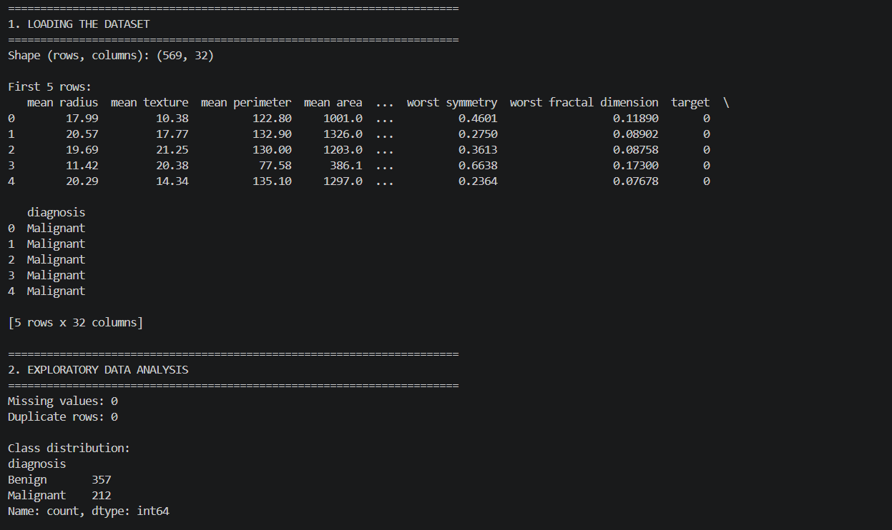
Output 1: Steps 1-2, loading the dataset and class distribution
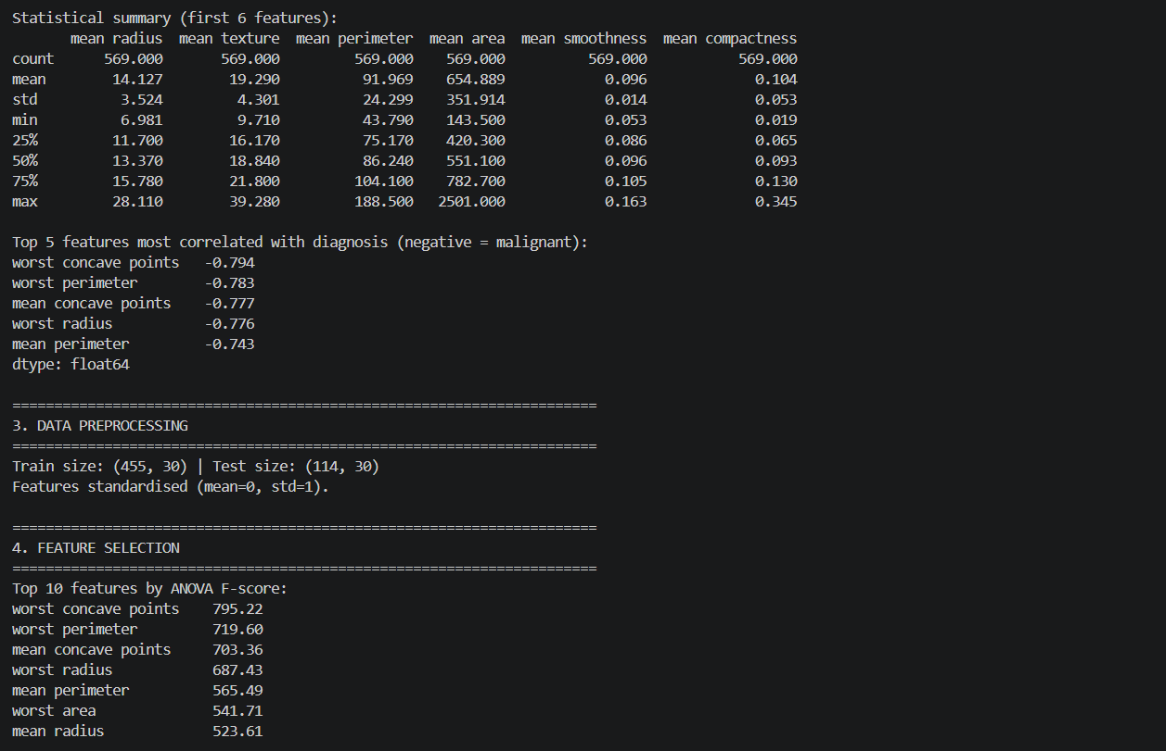
Output 2: Steps 2-4, statistics, correlation, preprocessing and ANOVA feature scores
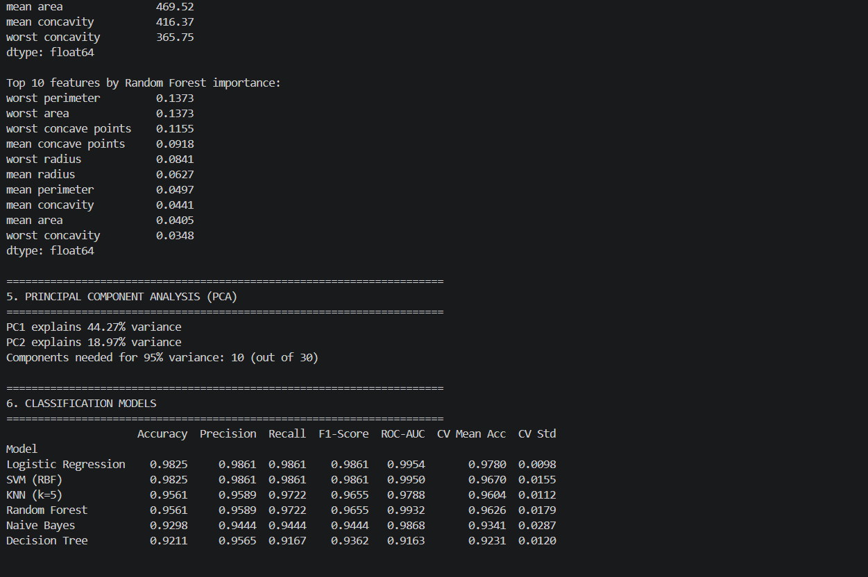
Output 3: Steps 4-6, feature importance, PCA and model comparison
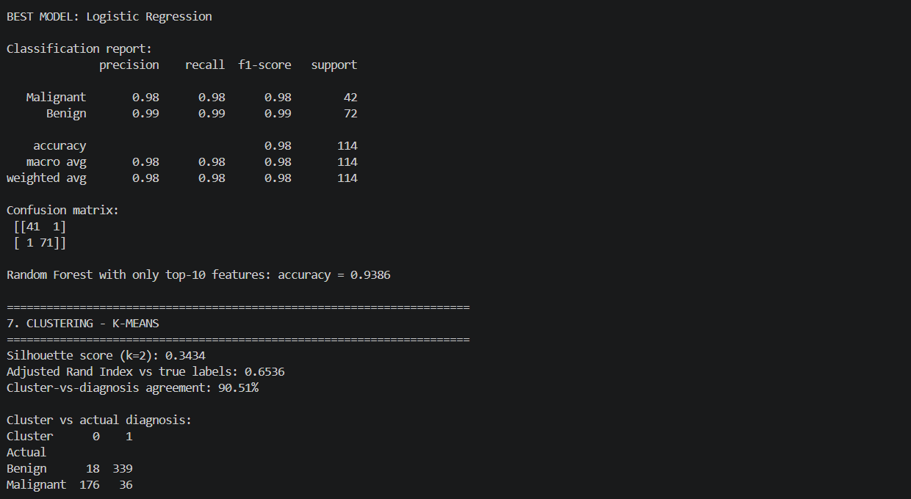
Output 4: Steps 6-7, best model report, confusion matrix and K-Means
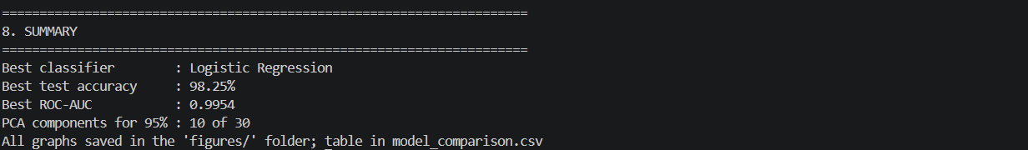
Output 5: Step 8, summary of results

7. Tables and Graphs
Table 1: Results of the six models on the test data
Model | Accuracy | Precision | Recall | F1 | ROC-AUC | CV Acc.
Logistic Regression | 0.9825 | 0.9861 | 0.9861 | 0.9861 | 0.9954 | 0.9780
SVM (RBF) | 0.9825 | 0.9861 | 0.9861 | 0.9861 | 0.9950 | 0.9670
KNN (k=5) | 0.9561 | 0.9589 | 0.9722 | 0.9655 | 0.9788 | 0.9604
Random Forest | 0.9561 | 0.9589 | 0.9722 | 0.9655 | 0.9932 | 0.9626
Naive Bayes | 0.9298 | 0.9444 | 0.9444 | 0.9444 | 0.9868 | 0.9341
Decision Tree | 0.9211 | 0.9565 | 0.9167 | 0.9362 | 0.9163 | 0.9231

Table 2: Confusion matrix of the best model (Logistic Regression)
 | Predicted Malignant | Predicted Benign
Actual Malignant | 41 | 1
Actual Benign | 1 | 71

Table 3: K-Means clusters (k = 2) compared with the real diagnosis
Actual diagnosis | Cluster 0 | Cluster 1 | Total
Benign | 18 | 339 | 357
Malignant | 176 | 36 | 212

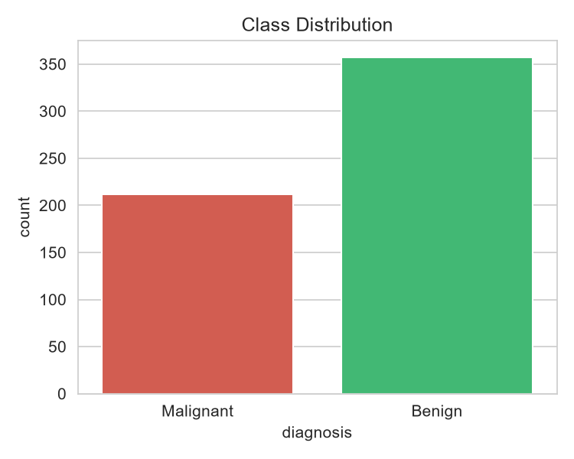
Figure 1: Class distribution (357 benign, 212 malignant)
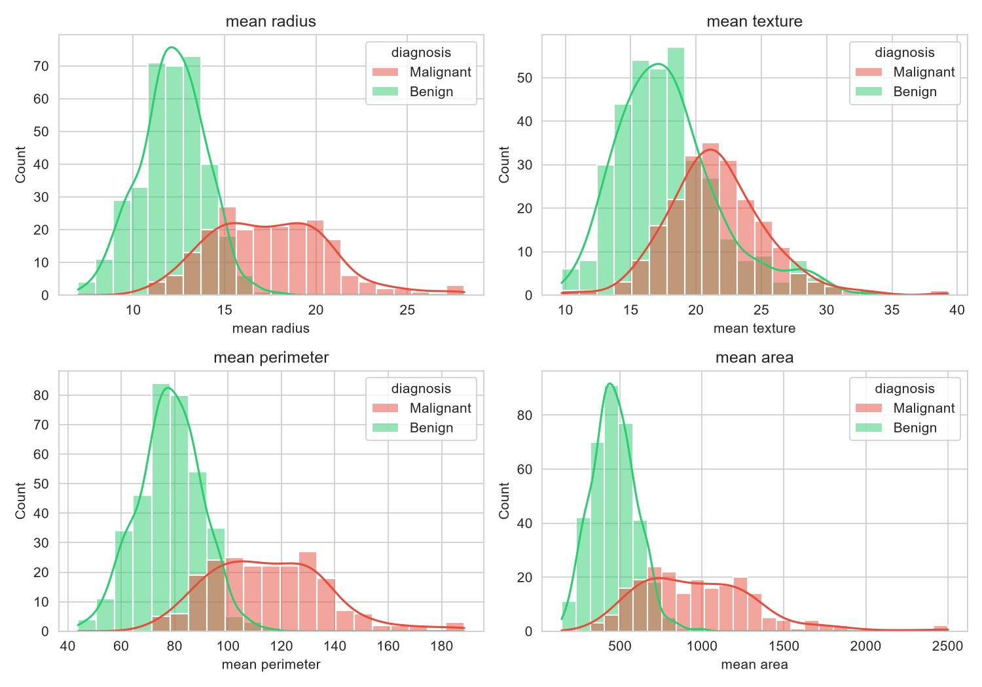
Figure 2: Distribution of key features by diagnosis
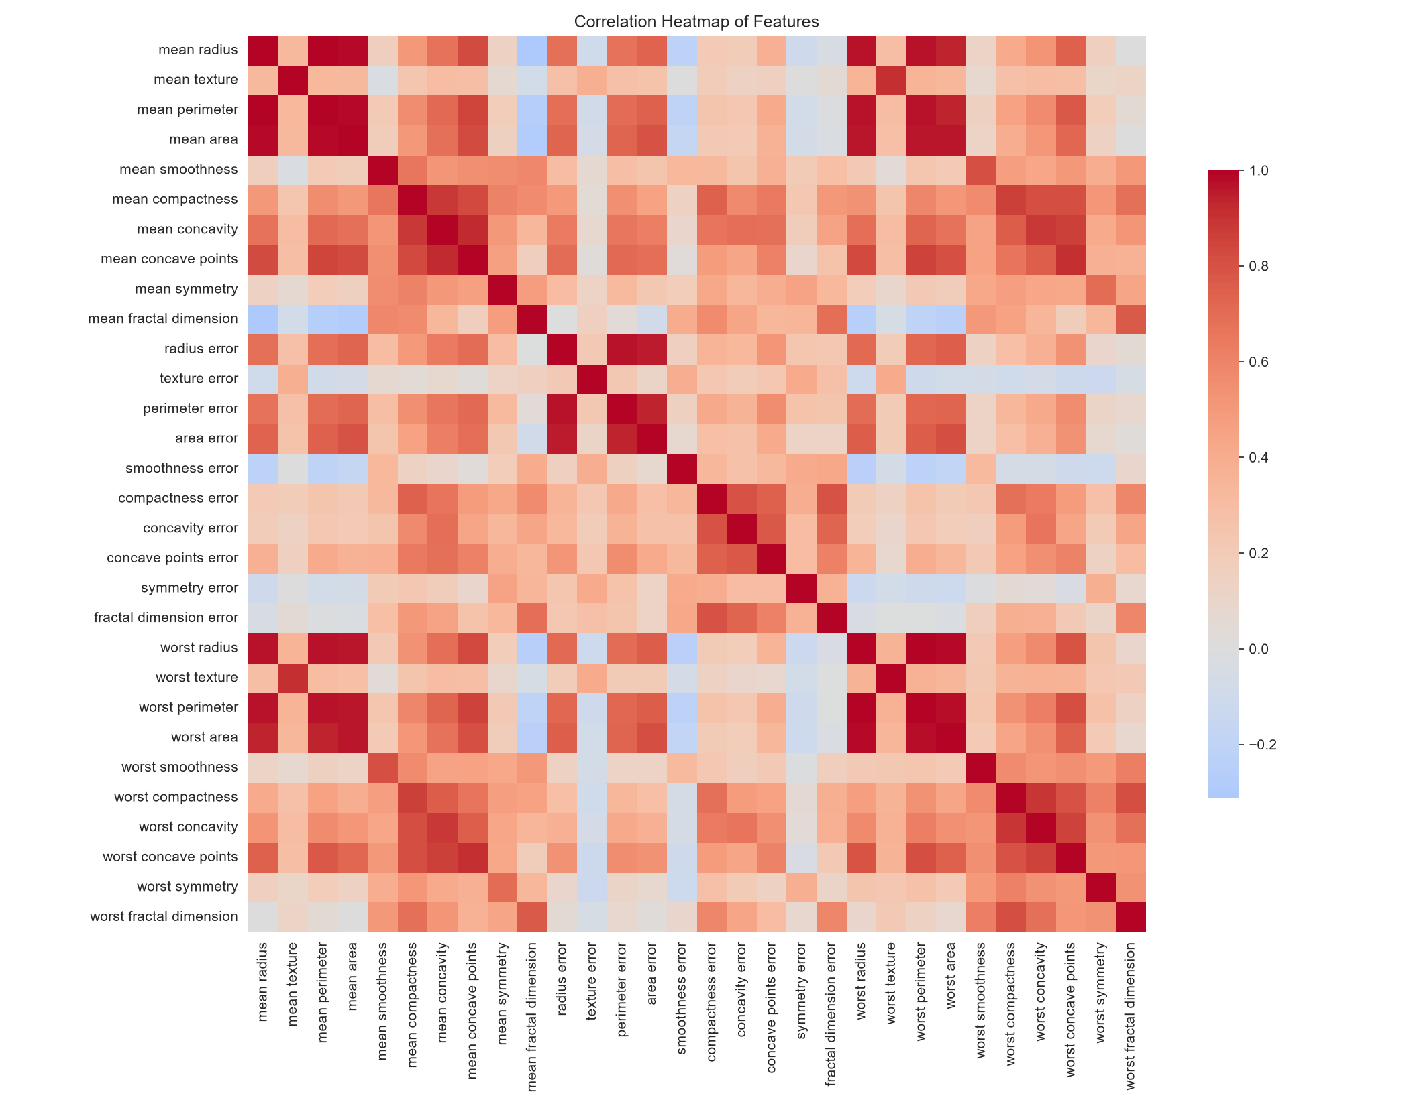
Figure 3: Correlation heatmap of the 30 features
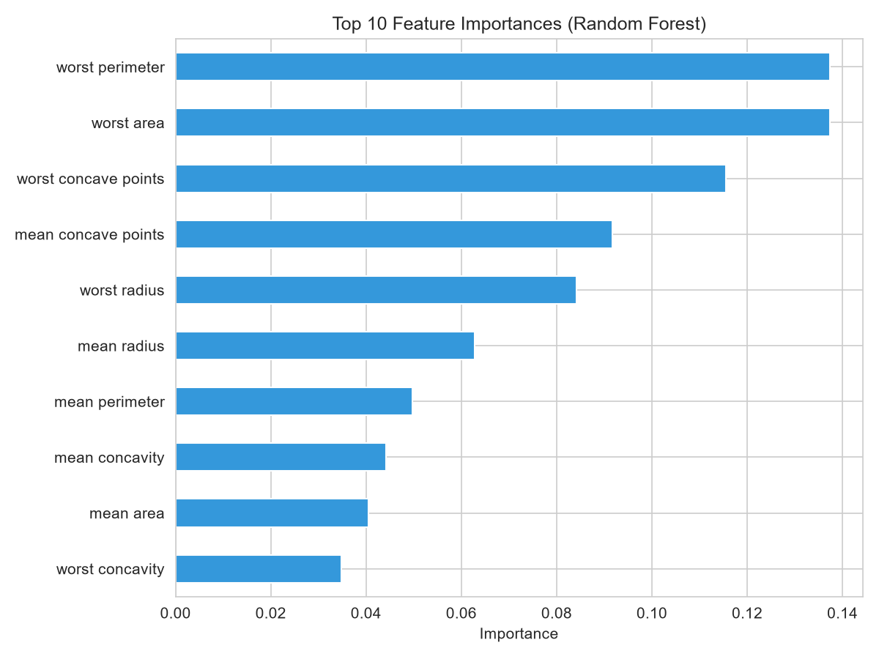
Figure 4: Top 10 feature importances (Random Forest)
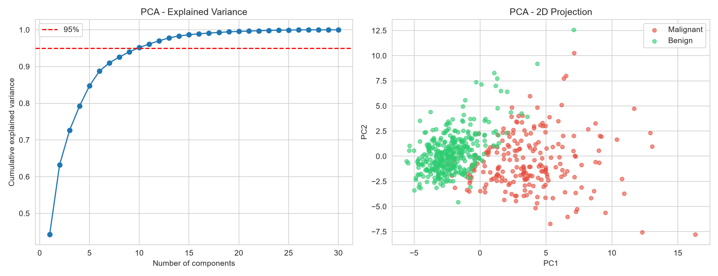
Figure 5: PCA, explained variance and 2D plot
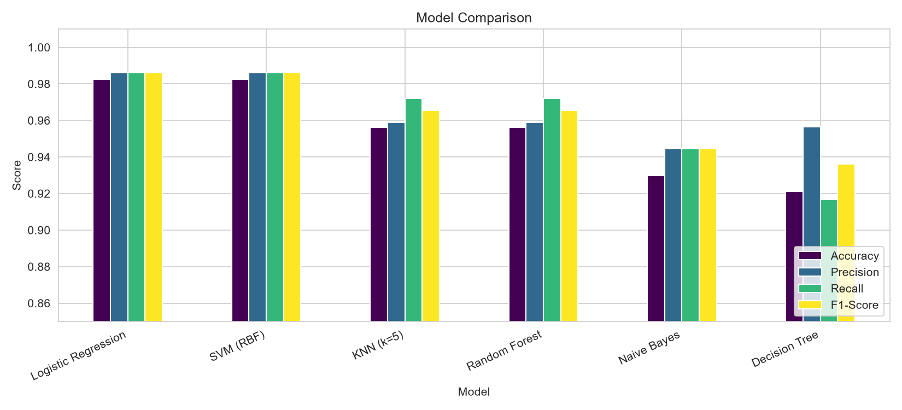
Figure 6: Comparison of the six models
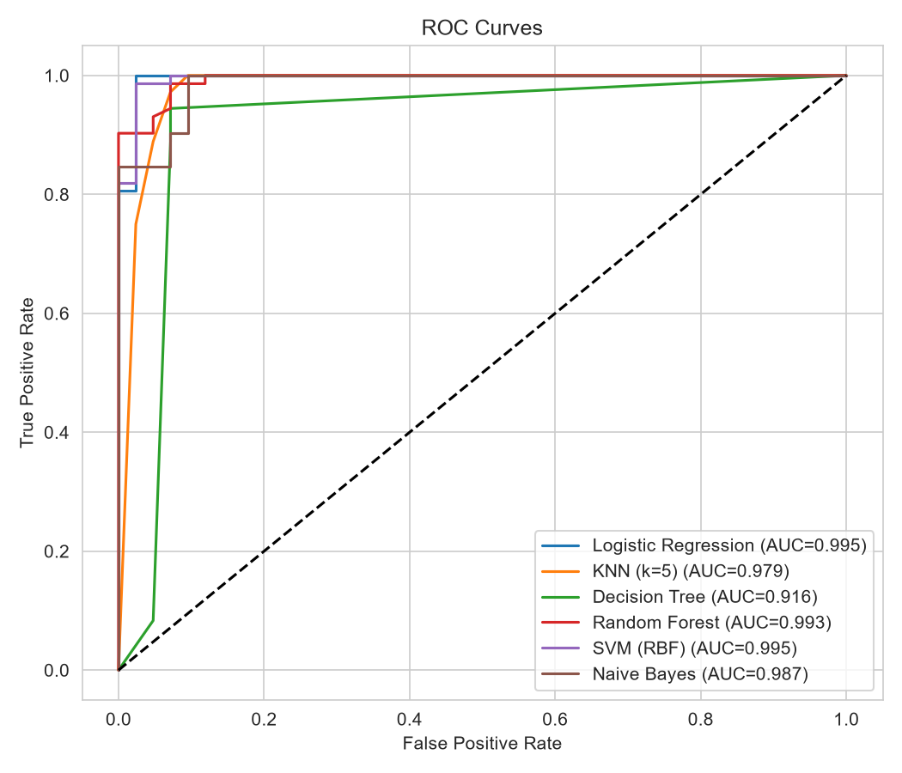
Figure 7: ROC curves of all models
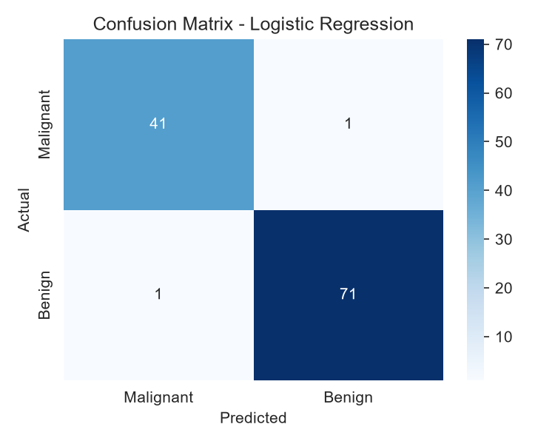
Figure 8: Confusion matrix of Logistic Regression
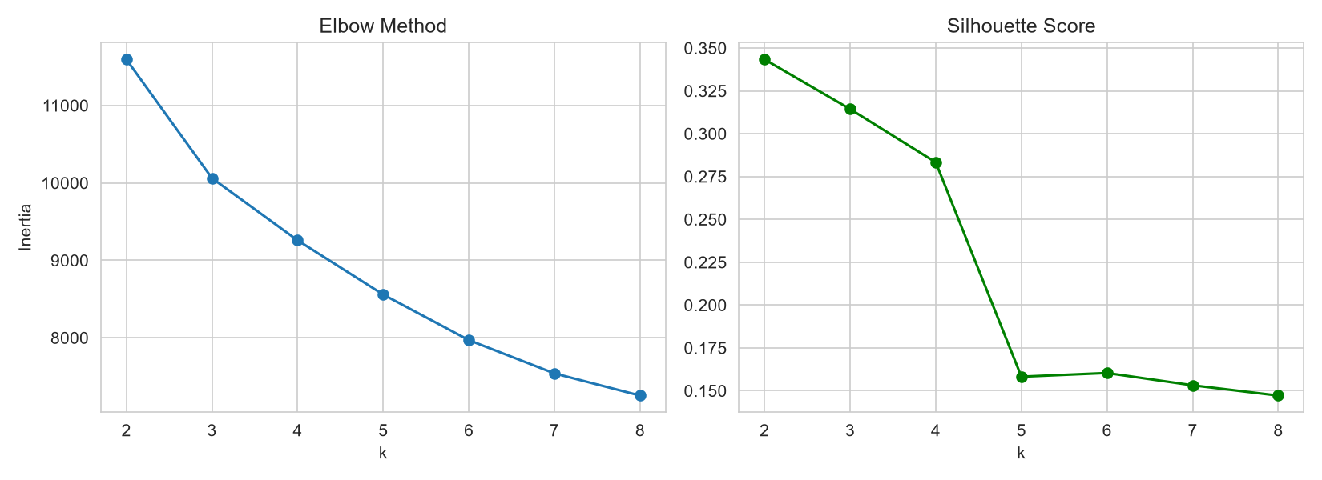
Figure 9: Elbow method and silhouette score for K-Means
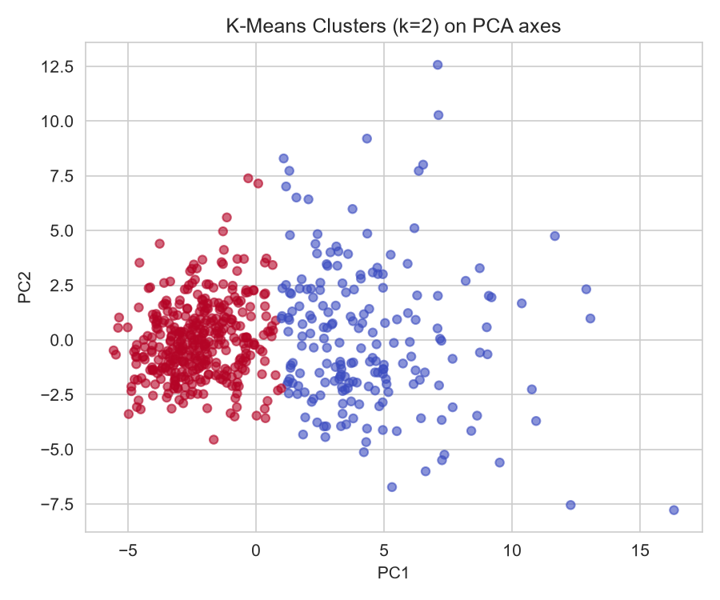
Figure 10: K-Means clusters (k = 2) on the PCA axes

8. Analysis
- The data has no missing values, so no cleaning was needed. 357 patients are benign and 212 are malignant (Figure 1).
- Malignant tumours have bigger radius, perimeter and area than benign ones (Figure 2). These three features are very closely related to each other (Figure 3).
- The most useful features were worst perimeter, worst area and worst concave points. Both methods gave the same top 10 features (Figure 4).
- With PCA, 2 components keep 63% of the information and 10 components keep 95% (Figure 5). In the 2D graph, malignant and benign patients are mostly separate.
- Logistic Regression and SVM gave the best result: 98.25% accuracy (Table 1, Figures 6 and 7). Logistic Regression was also the best in cross-validation (97.8%).
- The Decision Tree was the lowest (92.1%). Random Forest, which uses many trees together, did better (95.6%).
- Logistic Regression made only 2 mistakes out of 114 test patients. In one of them, a cancer patient was predicted as benign (Table 2, Figure 8).
- K-Means, without using the diagnosis, still matched the real diagnosis for 90.5% of the patients (Table 3, Figure 10). The silhouette score was best for 2 clusters (Figure 9). But the supervised models are better than K-Means.
- Random Forest with only the top 10 features gave 93.9%, compared with 95.6% using all 30 features.
- Limits: the test data is small (114 patients), I did not tune the models, and the data is from one source. This project is only for learning and not for real medical use.

9. Conclusion
- Data mining can predict whether a tumour is cancer or not with very high accuracy on this dataset.
- The best models were Logistic Regression and SVM, with 98.25% accuracy.
- The size of the tumour (radius, perimeter, area) and the shape of its edge (concavity, concave points) are the most important features.
- In future, I can tune the models, try other models like XGBoost, and test on bigger data.

10. Sources and References
- Wolberg, W. H., Street, W. N., & Mangasarian, O. L. (1995). Breast Cancer Wisconsin (Diagnostic) [Dataset]. UCI Machine Learning Repository. https://doi.org/10.24432/C5DW2B
- Street, W. N., Wolberg, W. H., & Mangasarian, O. L. (1993). Nuclear feature extraction for breast tumor diagnosis. IS&T/SPIE Electronic Imaging, 1905, 861-870.
- Pedregosa, F., et al. (2011). Scikit-learn: Machine learning in Python. Journal of Machine Learning Research, 12, 2825-2830.
- Han, J., Kamber, M., & Pei, J. (2011). Data Mining: Concepts and Techniques (3rd ed.). Morgan Kaufmann.
- scikit-learn documentation: https://scikit-learn.org/stable/

